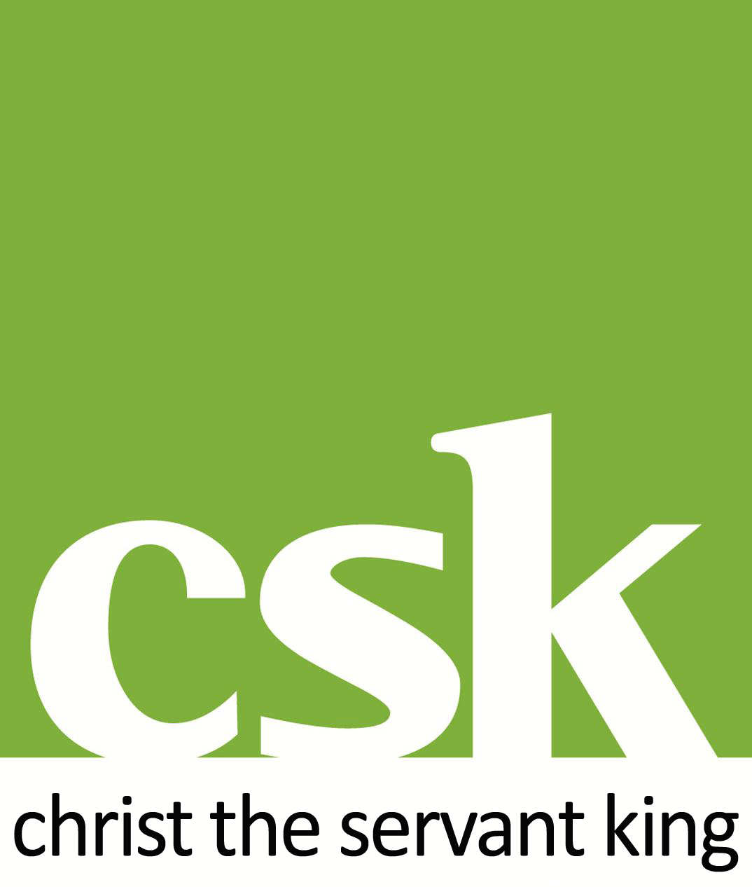
November 2022

CSK, Hampton, Peterborough (Ely Diocese)

Person Specification & Role Description for Full-Time Associate Minister

Vicar’s Letter

Thank you for looking at this job with us - we are in exciting times here!

I’m Rachel Hilditch and I became Vicar of this parish in July 2022, after joining as Curate in July 2016 and then becoming Associate Pioneer Minister - in large part, the same role as now being advertised. Hampton is a completely new development on the southwestern edge of Peterborough, begun at the turn of the millennium. The church began in a mobile building, and then met at a school throughout the 2000s, before moving into a brand new building in 2014 and lastly, the coffee shop part of our building (Chimes) opened in September 2015. All of the information about our church and its growth over the last few years can be found in the accompanying Parish Profile, so this letter is by way of a more personal introduction.

The truth is I never planned to stay here this long, but the Spirit has been doing too much for me to walk away! Jesus has built His church here and He is faithful. There are huge challenges of growth and building on our new land (gifted to us in 2019), as well as rising community demands, which need nothing short of supernatural answers. We cannot only do things in tried and tested ways; this is a season to have both the ability to pivot quickly and to make decisions from a heart of worship and prayer. The church is also on a journey of working out what it means to be a family of disciples on a mission together.

I love to see people set free and empowered into the fullness of all that God has for them. I tend to ask the question, ‘why not?’ rather than, ‘why should we?’ - we need to create a safe space to nurture creative, new, Jesus-centred ways of doing things. But above all, what I am really desperate to see is the end of ‘church as normal’; I pray we get less normal every week. Normal church is exhausting, hard to maintain and far too full of rotas. The church in Acts was the opposite of that, because it was full of life in the Spirit. We don’t need another Pentecost, as the song says, but we do urgently need whatever revival looks like in this century. Is this something you feel called to seek after too? Then maybe this post is for you.

The successful candidate will be a key part of our leadership team, working alongside me, our curate, the staff team and the lay leadership (PCC and other teams), as we discern the Lord’s plan for us on the next stage of CSK’s journey.

If you would like to know more before applying, please contact me on vicar@cskhampton.church or 01733 248124.

With love in Christ Jesus,
Rachel

Person Specification
Applicants will need to be ordained within the Church of England and have completed, or be about to complete, initial ministerial education. This is a full-time, incumbent-level position requiring a person of enthusiasm, energy and spiritual maturity.

We are looking for someone who is/can demonstrate:
Character
- A disciple, demonstrating the fruits of the Spirit
- Humble, teachable, approachable, servant-hearted and trustworthy
- Confident of her/his identity in Christ, and of her/his vocation as a leader
- Energetic, passionate and a self-starter - a natural pioneer
- Team player with the ability to discern gifts and skills in others

Spiritual life
- Evidence of a love for Jesus Christ through walking daily with the Spirit and a regular pattern of prayer and Bible study
- Evidence of seeing others come to faith through their ministry - and therefore a natural builder of relationships and sharer of the gospel with those not yet following Jesus
- Evidence of a love for the church, expressing itself in mature Christian relationships and a mature understanding of leadership
- Track record of bringing the Kingdom of God to our broken world: you have led and initiated community facing projects
- Boundaried in keeping rest days, in order to work from a place of rest

Theological convictions
- Gospel-centred, evangelical, Spirit-filled and Spirit-led
- Committed to the inspiration and authority of the Bible in matters of faith and conduct
- Fully committed to the leadership of women and men
- Convinced of the importance of context-specific mission when sharing the Gospel
- Willing to work with gentleness and generosity within the diversity of the local church and diocese
- Looking for unity in a collaborative culture, valuing alternative views

Gifts and skills
- A trainer of others, able to identify, inspire and equip church members in finding their calling in the church and beyond
- An excellent communicator - oral, written and via social media
- A preacher/service-leader who can inspire, nurture and equip a large congregation of all ages and backgrounds, through uplifting Bible teaching and charismatic worship
- Excellent interpersonal skills, emotional intelligence and ability to listen
- A track record of effective mission leadership, who can initiate, manage and empower new ministries/expressions of church
- A leader who engages positively with change, strategy, forward planning and setting/monitoring objectives
- Proficient in using modern technology
- Experience of line management

Role Description
The exact role will be shaped around the successful candidate, however main areas of focus include:

- Sharing ministry and leadership responsibility with the vicar in a large and growing church, acting in unison of purpose; able to deputise for the vicar.
- Heading up mission and outreach in our community, with particular responsibility for East Hampton, including planting, fresh expressions or similar ministry.
- Pastoring and sharing the Gospel with those members of our community who engage with our coffee shop, Chimes, and helping to support its ministry.
- Oversight of either our youth work and line management of our Youth Leader, and/or our Children’s Leader.
- In collaboration with the vicar of the neighbouring parish of Yaxley (in whose parish Great Haddon development lies), mentoring pioneer work in Great Haddon, as the development begins.

Shared responsibilities include:

- Leading prayer and worship and building a leadership team at CSK on Sundays and mid-week.
- Improving our discipleship, including the leading of Alpha and home groups.
- Creating the necessary structures to engage and mobilise the whole church in the next missional steps for CSK, enabling future growth.
- Being rooted in the pastoral life of Hampton, recognising that it is an area of high social need.
- Working with all our schools, primary and secondary – leading assemblies, supporting head teachers, alert to opportunities.
- Partnering with deanery colleagues and community organisations to bring fresh investment and build resilience in a developing community.
- Understanding, teaching and always observing and applying safeguarding requirements.
- Leading Occasional offices with imagination and kindness.

Essential requirements:
- Attending and supporting deanery chapter and synod, playing a full role in the Diocese of Ely as an example and champion of pioneering.
- Following at all times the Guidelines for the professional conduct of the clergy.

You will be responsible to the vicar of Hampton, working within the deanery plan.
Your final role description and objectives will be agreed and signed off by the Archdeacon of Huntingdon and Wisbech after a period of discernment and in collaboration with the vicar.
You will hold this post under Common Tenure for an initial period of 5 years.

